**CIS 375 – Fall 2019 Term Project - BRAINS**



Use Case Specification Document

**2**

**Login and Account Interaction**

**Version No. 1.1.0**

**Project Document Revision History**

|  |  |  |  |
| --- | --- | --- | --- |
| **VersionNumber** | **Date** | **Revision Author** | **Description of Revision** |
| 1.0.0 | 10/27/2019 | Kevin Longwroth | Creation of document |
| 1.0.1 | 10/28/2019 | Kevin Longworth | Revision of table of contents formatting |
| 1.1.0 | 10/30/2019 | Kevin Longworth | Edited swimlane diagram |

|  |
| --- |
| **Table of Contents** |

1. Introduction 4

2. Use Case Information 4

2.1 Actors 4

2.2 Use Case Interaction 4

3. Trigger 4

4. Pre-condition(s) 4

4.1 The user must already have a login in order for this use case to be done successfully 4

5. Post-condition(s) 5

5.1 The user logs in successfully 5

5.2 The user enters in the wrong credentials and is rejected 5

5.3 The user receives their password 5

5.4 The Oversight team creates a new user 5

6. Use Case Swimlane (Activity) Diagram 5

7. Main/Basic Flow(s) of Events (Happy Path) 5

7.1 The user logins, and is able to access the process he has rights to. 5

8. Alternate/Exception Flow of Events 6

8.1 The user inputs wrong username/password, and is rejected 6

8.2 Oversight Team logs in, doesn’t create a new user/department due to it already being found 6

9. Assumptions/Business Rules including Non-Functional Requirements 6

10. Use Case Specification Review and Signoff 6

# Introduction

This use case goes over the process of users logging in, as well as how new accounts will be created for more users to use the software. The user can request a new password, login, and the oversight team will give each user access level and what screen they will see depending on what department they are apart of.

Write a single paragraph describing the purpose of the specific use case in the Introduction.

# Use Case Information

## Actors

An actor is someone or something (e.g. application system) outside the system or business that interacts with the application. For every Use Case, there must be at least one Main Actor and zero or more Secondary Actors. Actors should be a person, system, or time.

|  |  |  |
| --- | --- | --- |
| Actor Name | Role | Description |
| Audit Company | Main | Using the login to access the STENER reports |
| Database | Secondary | This will be saving the data for each login, and relaying the proper credentials when trying to login |
| Departments | Main | Using the login system to answer the STENERs |
| Oversight Team | Main | They will be creating new users and their logins |

## Use Case Interaction

How does this use case relate to other uses cases? List predecessor and successor use cases.

This use case precedes all other use cases, because in order to access the other use cases, the user must login to the system.

# Trigger

What causes the use case to initiate?

Starting up the software will trigger this use case to begin.

# Pre-condition(s)

What use cases or other pre-conditions must be met before use can initiate?

## The user must already have a login in order for this use case to be done successfully

# Post-condition(s)

What are ALL the possible output states upon completion of the use case flows?

## The user logs in successfully

## The user enters in the wrong credentials and is rejected

## The user receives their password

## The Oversight team creates a new user

# Use Case Swimlane (Activity) Diagram

Draw diagram(s) that cover ALL main and alternate flows.

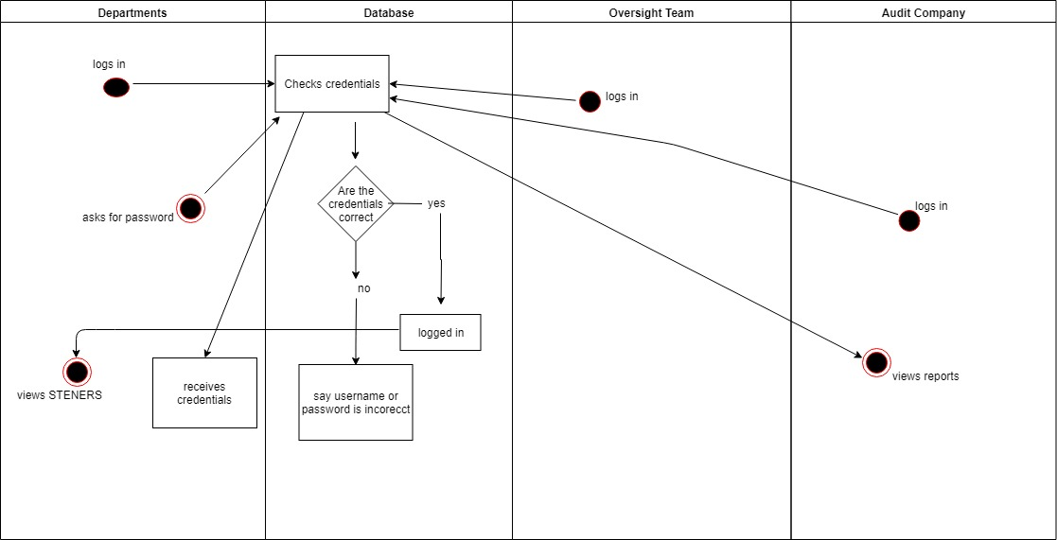

# Main/Basic Flow(s) of Events (Happy Path)

For each main flow (usually ONE flow) write the list of steps that occur – describe WHAT occurs not HOW to do it!

## The user logins, and is able to access the process he has rights to.

* + 1. if audit company, can read submitted reports
    2. if Oversight Team, create user/departments and upload/receive STENERS
    3. if Departments: upload/download STENERS

# Alternate/Exception Flow of Events

For each alternative flow (can be zero or more) write the list of steps that occur – describe WHAT occurs not HOW to do it!

## The user inputs wrong username/password, and is rejected

* + 1. Attempt to forgot password
       1. if passed the forget password test, than let the user input new password
       2. else reject current user, block ip address from logging, and send email to Oversight team of a potential break in.

## Oversight Team logs in, doesn’t create a new user/department due to it already being found

# Assumptions/Business Rules including Non-Functional Requirements

Each user will have a different access level depending on who they are with. It is also assumed that only people on the oversight team will have access to the oversight page.

# Use Case Specification Review and Signoff

|  |  |  |  |
| --- | --- | --- | --- |
| Review and Signoff of the Use Case Specification | | | |
| Name | Project Team Role | Signature | Date |
| Ahmed, Zakariya | Senior Tech Lead/SPMP manager | Z.A. | 10/30/19 |
| Alhaidar, Muaz | Developer | M.A. | 10/30/19 |
| Longworth, Kevin | Developer | K.L. | 10/30/19 |
| Labut, Cameron | Developer | C.L. | 10/30/19 |
| Majzoub, Mostafa El | Developer | M.M | 10/30/19 |